
STK-HD-OMS CAM-OV02778-SPEC
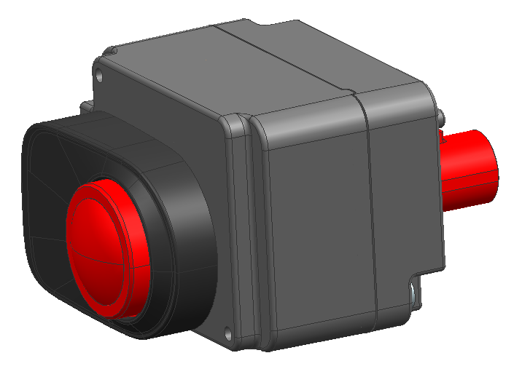
2MP OMS CAM(乘客检测摄像头)
基本描述/General Description
合肥晟泰克车载摄像头采用高动态车规图像传感器,配合主流串行传输芯片,使得该模组具有高可靠性能, 该模组具有广泛适用性，能适配不同的SOC 平台。
Vehicle camera module of Hefei Softec adopts high dynamic vehicle gauge image sensor, with mainstream serial transmission chip, making the module has high reliability performance, the module has a wide range of applicability, can be adapted to different SOC platforms.
特点/Features
● 车规高性能/High Performance Automotive Grade;
● 传感器高动态范围/Advanced On−Sensor HDR;
● 支持识别人脸等多功能/Support face recognition and other functions
应用/Application
● 舱内遗留物监测Cockpit residue monitoring
● 安全带，乘客检测/Seat belts, passenger detection
● 面部识别/Facial recognition

硬件框图/Hardware block diagram
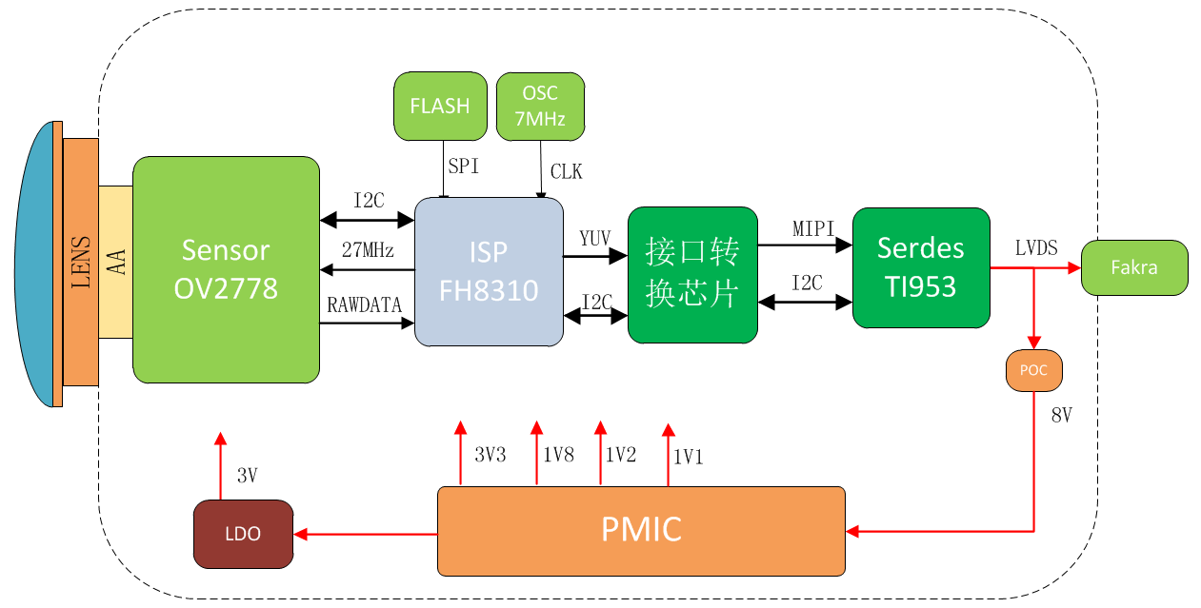

关键参数/ KEY PARAMETERS
序号 | Sensor参数 | OV OV02778
1 | Active Pixels(有效像素) | 2MP
2 | Image Size(图像尺寸) | 1/2.9-inch CMOS
3 | Shutter Type(曝光模式) | Rolling Shutter 卷帘快门
4 | Output Pixels(输出像素) | 1920*1080
5 | Pixel Size(像素尺寸) | 2.8um*2.8um
6 | ISP参数 | FH8310
7 | Frame Rate(帧率) | 30fps
8 | Output data(输出信号格式) | YUV422
9 | Lens参数 | LC-C30-45B（信华）
10 | Lens Type(镜头结构) | 6G+IR
11 | F/No. | 2.6±5%
12 | EFL | 2.58±5%
13 | F.O.V(Horizontal/Vertical) | H:120.2°±3°,V:67.4°±3°  D:137.6°±3° (1080P)
14 | TV Distortion(TV畸变) | <-18.5%
15 | Relative Illumination(相对照度) | >55%@DFOV
16 | Focusing Distance(调焦距离，物距) | 1000mm(按应用的物距)
17 | Depth of Field(景深范围) | 686.26mm-infinity
18 | 整体模组 | 参数
19 | Dimensions(尺寸) | L: 35mm, W:25mm, H:45mm
20 | Weight(重量) | ＜50g
21 | Connector(连接器) | Amphenol (安费诺)-SMBF-FKMZ3-3GT30G-50
22 | Serializer(串行器) | TI DS90UB953
23 | Power Supply(工作电压) | 7-9V
24 | Current(工作电流) | ＜500mA
25 | Camera Interface(摄像头接口) | LVDS
26 | Optical Axis Precision(光轴精度) | X:±5 Pixel,Y: ±5 Pixel;
27 | Startup Time(启动时间) | ≤500ms
28 | Operating temperature(工作温度) | -40℃~85℃
29 | Storage temperature(存储温度) | -40℃~95℃
30 | IP Grade(防护等级) | 模组本体IP52
31 | MTF(清晰度) | 中心视场：MTF50P≥0.55  0.7视场：MTF50P≥0.38
32 | Low Light(最低照度) | 0Lux（IR pattern）
33 | SNR(信噪比) | 42.6dB
34 | HDR Range(动态范围) | 120dB

附件Ⅰ：：摄像头本体尺寸示意图(单位：mm)
