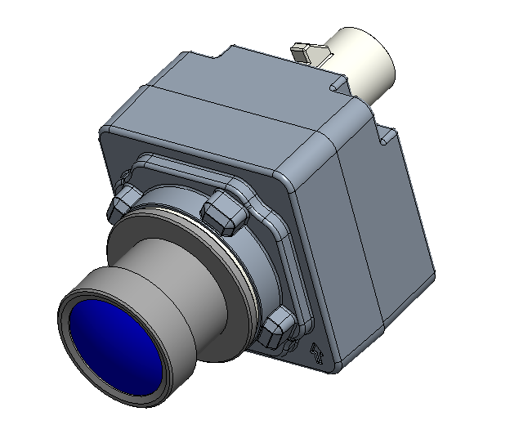

STK-HD-CAM-OX01C10-SPEC
2.5MP CAM(后视/周视摄像头)
基本描述/General Description
合肥晟泰克车载摄像头采用高动态车规图像传感器,配合主流串行传输芯片,使得该模组具有高可靠性能, 该模组具有广泛适用性，能适配不同的SOC 平台。
Vehicle camera module of Hefei Softec adopts high dynamic vehicle gauge image sensor, with mainstream serial transmission chip, making the module has high reliability performance, the module has a wide range of applicability, can be adapted to different SOC platforms.
特点/Features
● 车规高性能 /High Performance Automotive Grade;
● 传感器高动态范围/Advanced On−Sensor HDR;
● 支持多相机同步/Multi−Camera Synchronization Support;
● 多款不同焦距镜头可选/Support different focal length lens;
应用/Application
- 车载后视 /Rear View Camera
- 车载侧视 /Vehicle side view
- 高级辅助驾驶和视觉融合/ADAS + Viewing Fusion
- 高动态应用/High Dynamic Range Imaging

硬件框图/Hardware block diagram
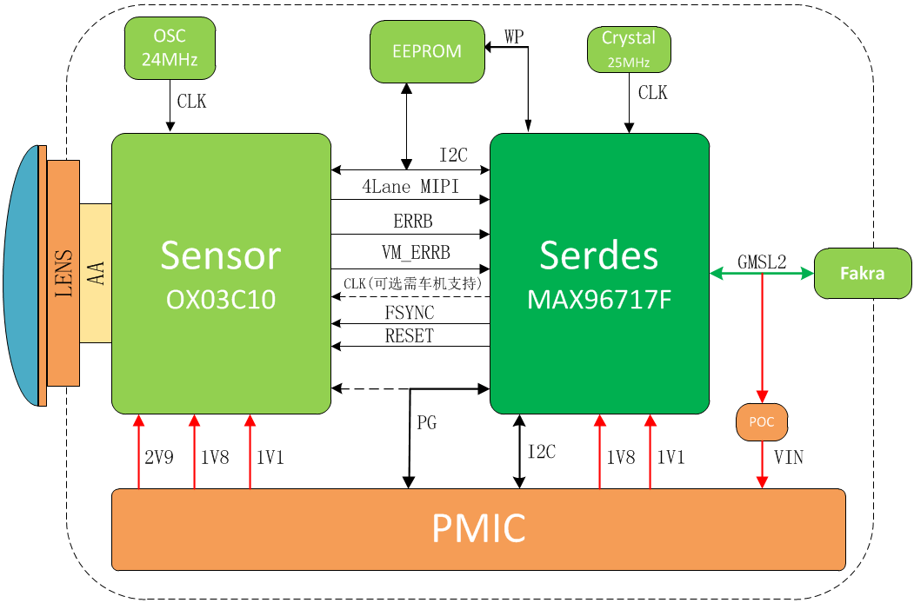

关键参数/ KEY PARAMETERS
序号 | Sensor参数 | OV OX01C10
1 | Active Pixels(有效像素) | 2.5MP
2 | Image Size(图像尺寸) | 1/2.6-inch CMOS
3 | Shutter Type(曝光模式) | Rolling Shutter 卷帘快门
4 | Output Pixels(输出像素) | 1920*1280
5 | Pixel Size(像素尺寸) | 3um*3um
6 | ISP参数 | 集成至Sensor
7 | Frame Rate(帧率) | 30fps
8 | Mirror(镜像) | 内置
9 | Output data(输出信号格式) | RAW
10 | Lens参数 | 后视：LC-C80-87A(信华)
11 | Lens Type(镜头结构) | 6G+IR
12 | F/No. | 1.60±5%
13 | E.F.L | 5.83±5%
14 | F.O.V(Horizontal/Vertical) | H:60°±3°,V:47°±3°
15 | OP Distortion(OP畸变) | -27.5±3% (@Φ7.38mm)
16 | Relative Illumination(相对照度) | 65±5% (@Φ7.38mm)
17 | Focusing Distance(调焦距离，物距) | 500mm(按应用的物距)
18 | Depth of Field(景深范围) | 50mm-infinity
19 | 整体模组 | 参数
20 | Dimensions(尺寸) | L: 25mm, W:25mm, H:45mm
21 | Weight(重量) | ＜50g
22 | Connector(连接器) | 电连-818010624
23 | Serializer(串行器) | MAXIM MAX96717F
24 | Power Supply(工作电压) | 7-9V
25 | Current(工作电流) | ＜200mA
26 | Camera Interface(摄像头接口) | LVDS
27 | Optical Axis Precision(光轴精度) | X:±5 Pixel,Y: ±5 Pixel;
28 | Startup Time(启动时间) | ≤500ms
29 | Operating temperature(工作温度) | -40℃~85℃
30 | Storage temperature(存储温度) | -40℃~95℃
31 | IP Grade(防护等级) | IP67，镜头处IP69
32 | MTF(清晰度) | 中心视场：＞0.55@Ny/2  0.7视场：＞0.38@Ny/2
33 | Low Light(最低照度) | 1Lux
34 | SNR(信噪比) | 41.6dB
35 | HDR Range(动态范围) | 140 dB HDR4 (DCG+SPD+VS)  120 dB HDR3 (DCG +VS)
36 | 固件点亮配置 | 参数
37 | VSYNC极性 | TBD
38 | 主从模式 | Slave
39 | 数据有效位 | 低八位
40 | I2C地址 | 0X6C
41 | 点亮配置 | TBD

附件Ⅰ：摄像头本体尺寸示意图(单位：mm)
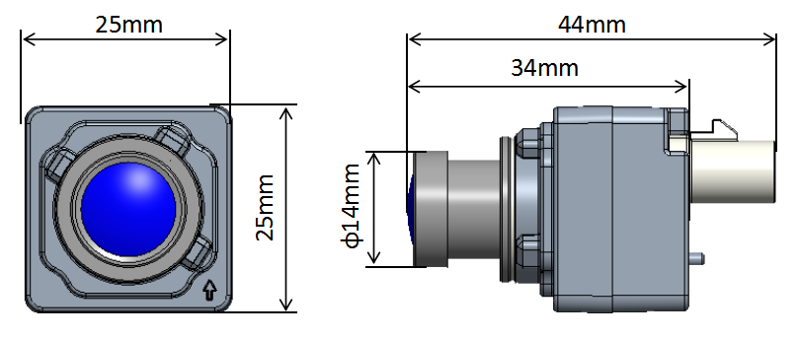
周视
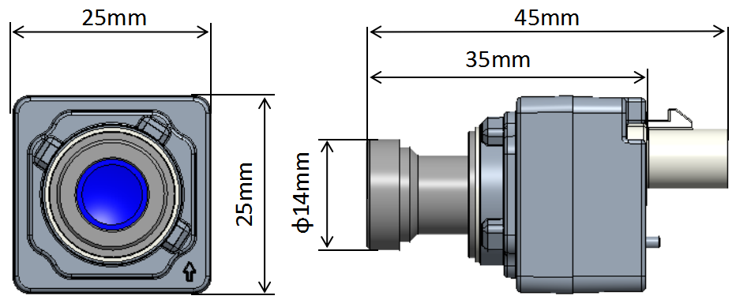
后视

